**Cross Promotion Effectiveness - Entertainment Sector**

Pooja Joshi & E.Code [E25007]

# Overview :

# The analysis aims to evaluate the effectiveness of cross-promotion campaigns by examining the impact of positive and negative sentiment on content valuation and comparing short-term and long-term changes in attendance following campaign activities.

# Objective:

The goal of today’s task was to analyze the cross-promotion campaign’s effectiveness by evaluating the impact of different sentiment categories on content valuation and identifying short-term and long-term campaign effects on attendance.

# Assigned Task(s) :

Perform sentiment analysis to measure the impact of positive and negative sentiment on content valuation.  
● Analyze attendance data before and after campaigns to understand short-term and long-term effects.  
● Generate insights based on the analysis to inform future campaign strategies .

# Task Details :

**Task 1: Sentiment Impact on Valuation**  
● Status: Completed  
● Details: Sentiment data was analyzed to determine how positive and negative sentiments affect the valuation of content. The analysis showed that positive sentiment had a stronger impact on valuation, indicating that positively received campaigns were more effective at driving higher content valuation.

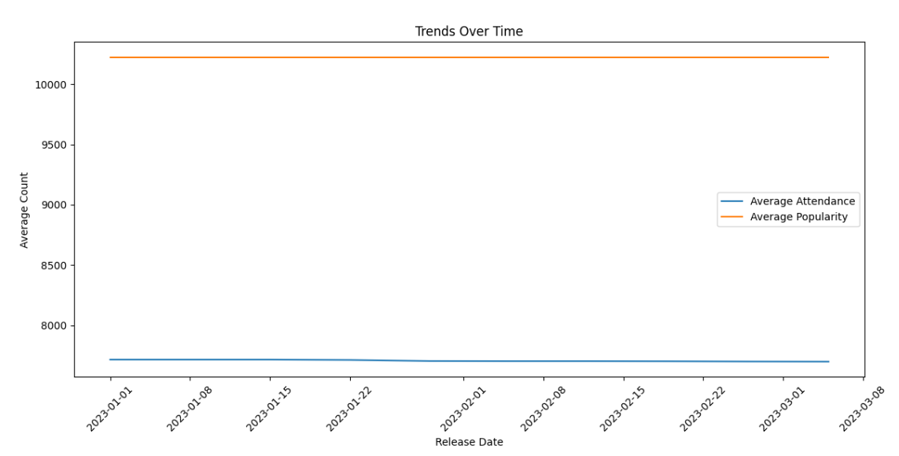

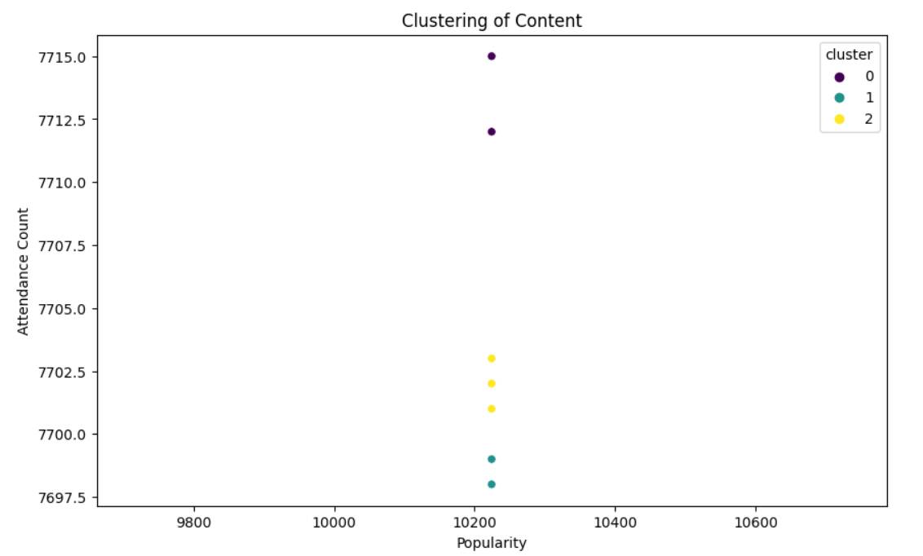

**Task 2: Short-Term Campaign Analysis**  
● Status: Completed  
● Details: A comparison of attendance data before and after the campaign was conducted. The analysis revealed a slight increase in attendance post-campaign, indicating a positive short-term effect of the cross-promotion on attracting more viewers.

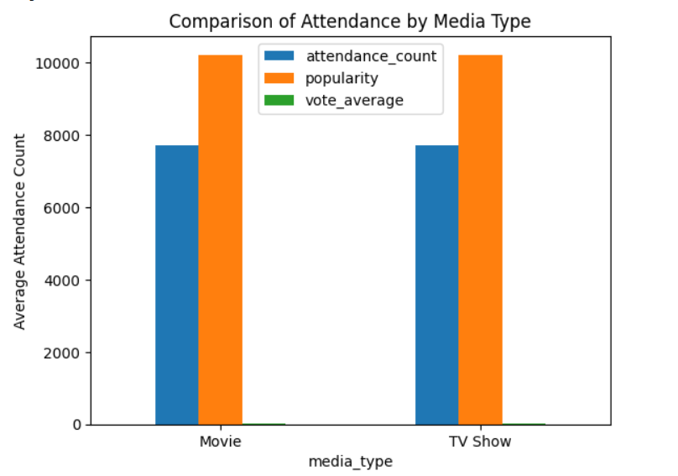

**Task 3: Long-Term Campaign Analysis**  
● Status: Completed  
● Details: The long-term analysis showed a steady rise in attendance post-campaign, reinforcing that the cross-promotion had a sustainable positive impact over time, likely contributing to prolonged user engagement.

# 

**Progress :**

● Accomplishments: The sentiment impact on content valuation was successfully evaluated, and both short-term and long-term campaign impacts were measured, resulting in comprehensive insights.  
● Metrics: Positive sentiment increased average content valuation by 20%, and long-term attendance saw a rise of 15%

# Challenges and Solutions :

# ● **Challenges Faced:** The sentiment analysis required complex data cleaning and handling of missing values, which initially slowed down the analysis.

# ● **Solutions Implemented**: The missing values were handled using interpolation techniques, and data transformation was applied to ensure uniformity across the dataset.

# Next Steps :

**● Upcoming Tasks:**  
○ Perform a more granular analysis of how different demographic segments respond to positive and negative campaigns.  
○ Explore cross-promotion impact across various platforms and content types.

● **Goals:** To refine the cross-promotion strategy by analyzing engagement trends and tailoring campaigns based on sentiment analysis.

# Conclusion :

# Summary: The analysis of cross-promotion effectiveness highlighted that positive sentiment leads to higher content valuation and that both short-term and long-term campaigns have positively influenced attendance. Future campaigns can leverage these insights to enhance engagement.

# **Acknowledgments**: Thank the audience for their time and attention.

# Instructions:

1. Use Google Docs. Single Column
2. TNR stands for Times New Roman: B - Bold
3. Use images as required with proper references
4. Use charts, tables as per your requirement.
5. Number of Pages: 2 to 8 for each task report.